**8 Email Hacks You Never Knew Existed**

[Get Off the table](https://www.youtube.com/watch?v=sr1iBfWCchs)

<div style="max-width:600px;margin:0 auto;text-align:center; mso-element-frame-width:600px; mso-element:para-border-div; mso-element-left:center; mso-element-wrap:no-wrap-beside;">

<!-- Content -->

</div>

* mso-element:para-border-div

我并没有找到para-border-div这个值，它应该是frame，因为用了mso-element-frame-width:600px;默认值是frame。

|  |  |  |  |
| --- | --- | --- | --- |
| mso-element | Office only | [Comments](mk:@MSITStore:C:\Users\myli\Desktop\microsoft-office-html-and-xml-reference\microsoft-office-html-and-xml-reference.chm::/html/Word/wdconComments.htm), [Headers and Footers](mk:@MSITStore:C:\Users\myli\Desktop\microsoft-office-html-and-xml-reference\microsoft-office-html-and-xml-reference.chm::/html/Concepts/ofconHeadersFootersStyle.htm) | comment,comment-list,dropcap-dropped,dropcap-in-margin,endnote,endnote-continuation-notice,endnote-continuation-separator,endnote-list,endnote-separator,field-begin,field-end,field-separator,footer,footnote,footnote-continuation-notice,footnote-continuation-separator,footnote-list,footnote-separator,frame,header,none,paragraph-mark-properties,table-head |

* mso-element-wrap:no-wrap-beside;

|  |  |  |  |
| --- | --- | --- | --- |
| mso-element-wrap | Office only | [Frames and Drop Caps](mk:@MSITStore:C:\Users\myli\Desktop\microsoft-office-html-and-xml-reference\microsoft-office-html-and-xml-reference.chm::/html/Word/wdconFramesandDropCaps.htm) | around,auto,none,no-wrap-beside |

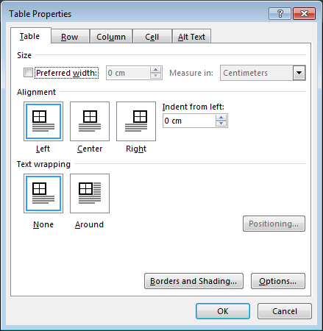

Table的text wrapping貌似只有none和around这两个值，个人感觉这个no-wrap-beside应该是作用于图片的。

 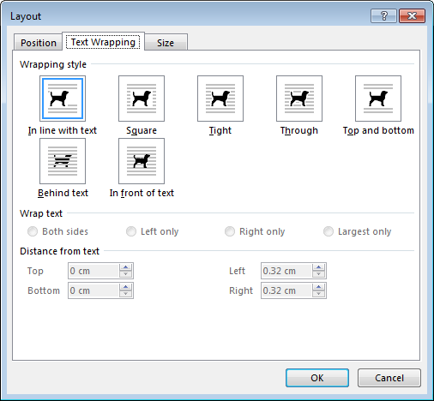

* max-width:600px;

这个不知道为什么用max-width, 我用超过max-width的图片，整个table的宽度还是超过600的，留待深究。

详情请参见代码。

[Duo-Toner by Kimberly Connell](https://www.youtube.com/watch?v=2FrebfP968A)

https://codepen.io/cvasquez/full/yXaxRR/

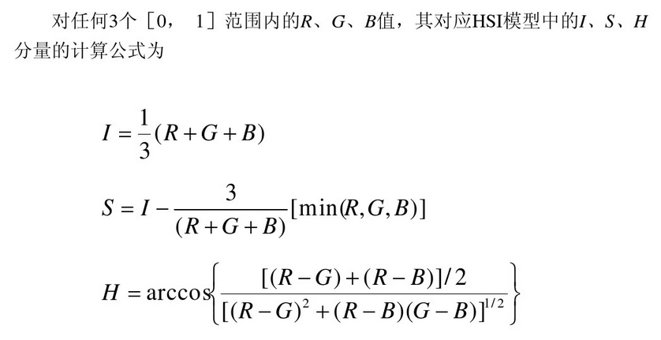

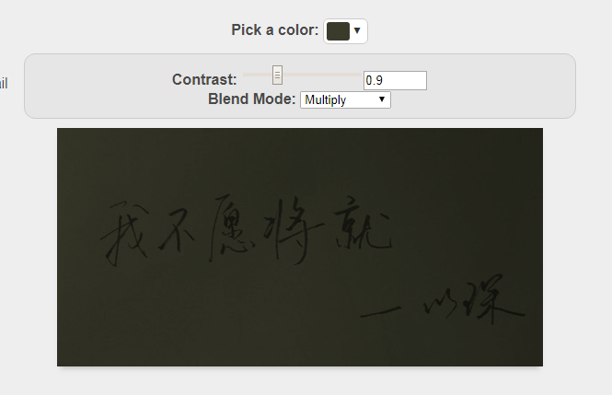

色相 对比度 混合模式

[Add to Calendar Links By Kevin Mandeville](https://www.youtube.com/watch?v=BMI5QZQXgJA)

<https://confluence.merkleinc.com/display/DMT/Add+Calendar+Events+To+Email>

[An Alternative Theory by Steven Collins](https://www.youtube.com/watch?v=XS-CPncIsjo)

详情参见代码

[Email Camera by Remi Parmentier](https://www.youtube.com/watch?v=m9u11l_7Y2A)

<input type="color"> (H5)

<input type="file">

[MJML by Nicolas Garnier](https://www.youtube.com/watch?v=9xI8RekYxME)

<https://mjml.io/>

[VW to the Rescue by Wilbert Heinen](https://www.youtube.com/watch?v=alNdmC1Ojtw)

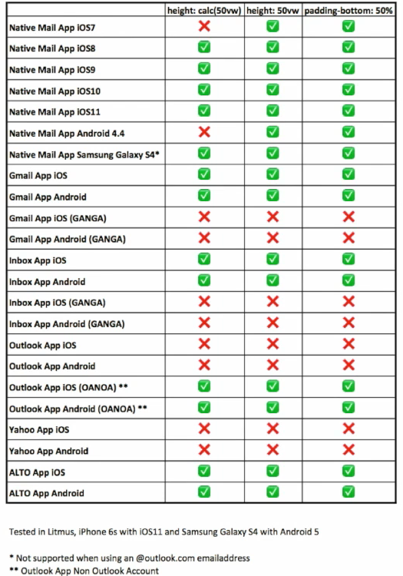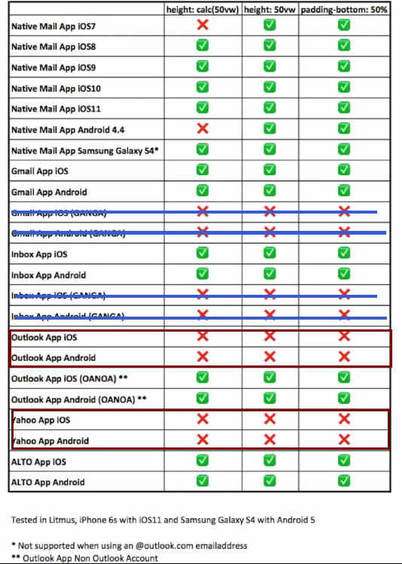

**GANGA** (Gmail App with a Non Google Account)

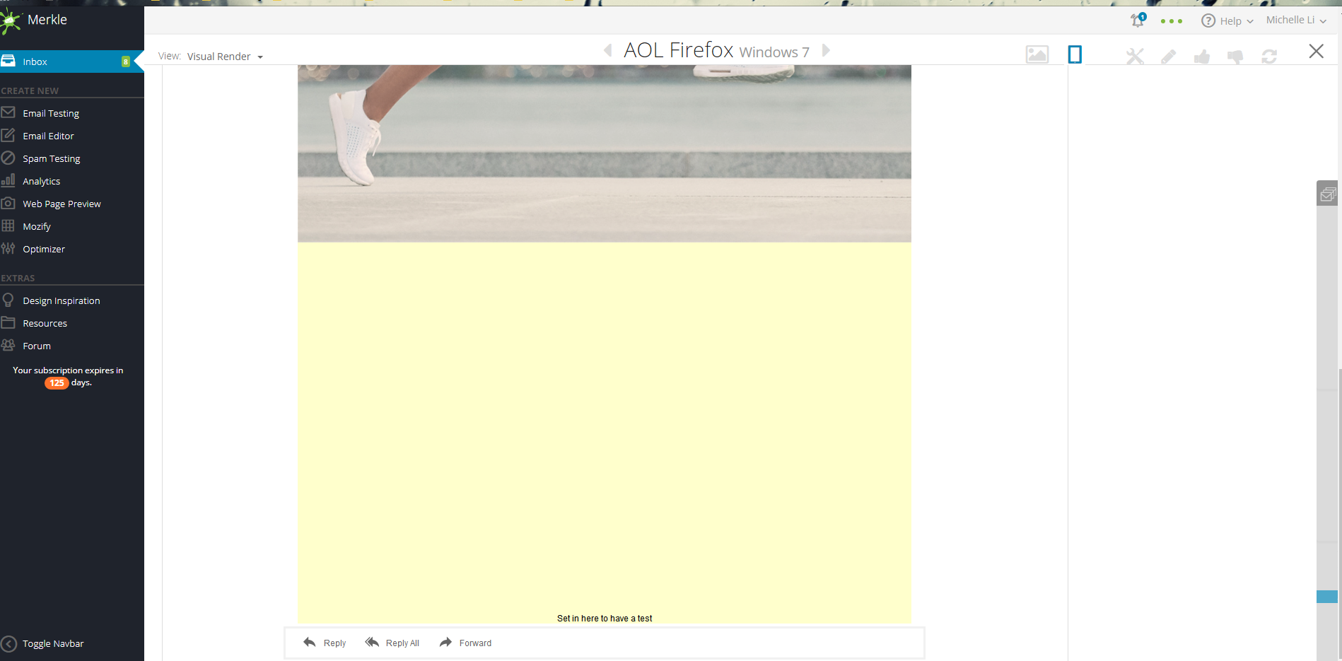

Yahoo不支持vw/vh，桌面版email禁用，GANGA不能用

[The &zwnj;&nbsp; Preview Text Hack by Jaina Mistry](https://www.youtube.com/watch?v=d5lwydFLnd4)

和加中文状态下的空格是一个思路，

http://www.fileformat.info/info/unicode/category/Zs/list.htm

**zero-width non-joiner** (**ZWNJ**) (HTML &#8204; **·** &zwnj;) 很棒不断行 [Unicode 1.1.0 (June, 1993)](http://www.fileformat.info/info/unicode/version/1.1/index.htm)

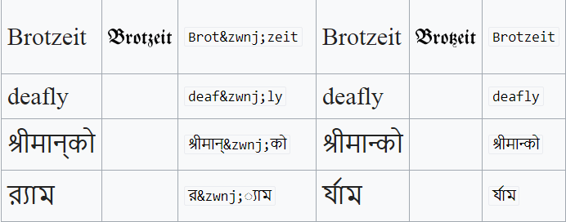

**zero-width joiner** (**ZWJ**) (HTML &#8205; **·** &zwj;) 很棒不断行 [Unicode 1.1.0 (June, 1993)](https://www.fileformat.info/info/unicode/version/1.1/index.htm)

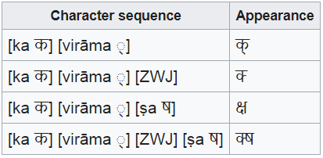

**zero-width space** (**ZWSP**)  (HTML &#8203; ) 自然断行 [nicode 1.1.0 (June, 1993)](https://www.fileformat.info/info/unicode/version/1.1/index.htm)

**zero-width no-break space** (HTML &#65279;) [Unicode 1.1.0 (June, 1993)](http://www.fileformat.info/info/unicode/version/1.1/index.htm)

**&#8239, narrow no-break space**